Research - Riget Zoo Adventures (RZA)

2024 – Occupational Specialism.

# Activity A (i)

## Research

### How is hardware and software used within the context of the industry?

Within the context of the industry, hardware and software are utilized extensively to optimise operation, enrich customer experiences to optimise.

1. Ticket and reservation systems.
2. Interactive displays
3. Mobile application
4. Customer Relationship Management

People will use websites to book an educational visit or leisure on their computers of mobile device. They would need a lot of details to get more in depth information to reserve and book a zoo’s services.

An example of a reserving and booking system is: <https://www.booking.com/>



As you can see here, the website Booking.com has two 3 clear options for the user to input then. They include a check-in date & Check-out date, the number of adults, children and rooms the user can book and a search button.

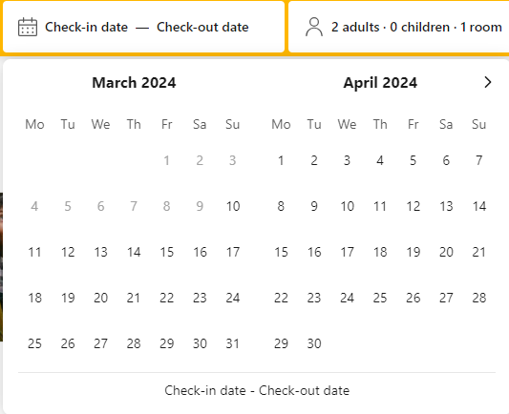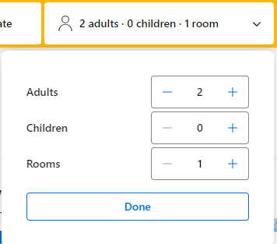

Here we can check availability of a room and how much it will cost for the amount of nights, the details of your choices, the amount of guests, what room is available and allows the user to input how many rooms they would want. On the very right, there is a reserve button which allows the user to reserve a room quickly and efficiently.

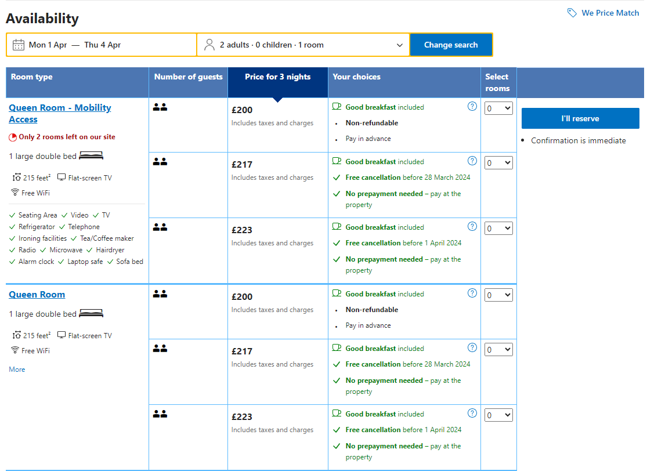

An example of a ticketing and booking system is [Visit Chester Zoo](https://shop.chesterzoo.org/): 